Alice Rogene
WDD 131- Section 1

Overview
Purpose:
- Our website connects individuals with nonprofit organizations to protect, heal, and empower children, helping every child grow up healthy, safe, and full of hope. Hopefully, this site helps connect families with organizations that can provide funding or guidance for their situation.

Audience:
- Parents and guardians who are looking for nonprofits that can help their children thrive.

Dynamic elements:
- Event listeners - so when the user clicks on the crescent moon icon, the page goes into dark mode (possibly), so that when the user enters information, the search information shows up
- Objects - all the information will be stored in objects
- Arrays- tags will be stored in arrays because several non-profits fall under various categories
- forEach loop - helps me add the content to the page
- Filter - helps decipher what information I want to show up on the page
- Modal- if the user clicks on the information card, it should open up in the modal with the current information
- etc.

Branding
Website Logo
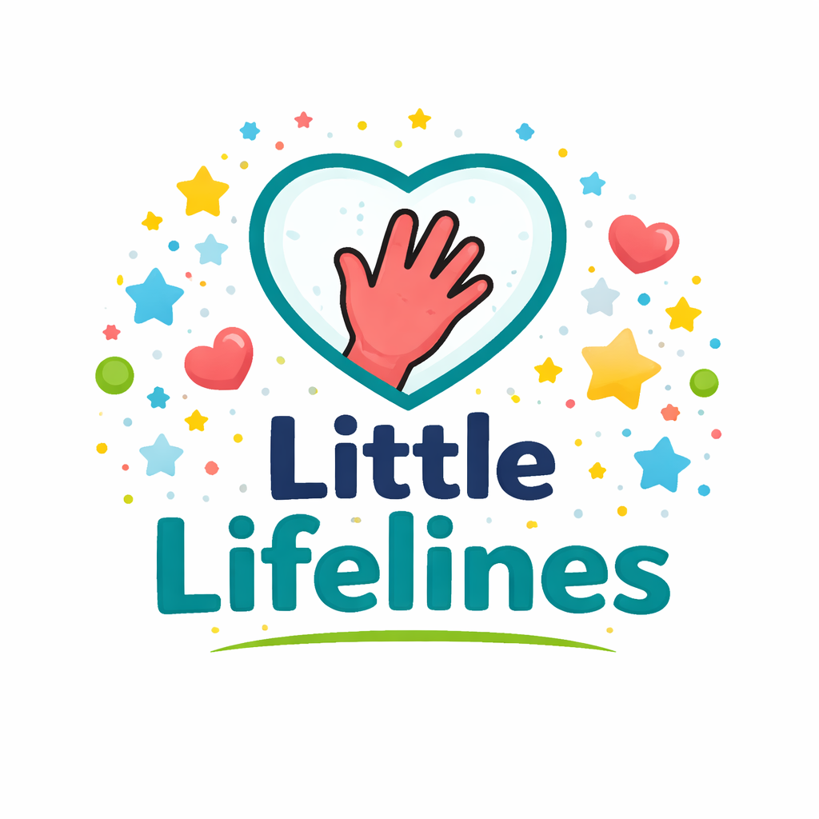

Style Guide

Primary | Secondary | Accent 1 | Accent 2
[#2c3e70]-  Indigo | [#f25f5c]-  coral | [#6ec5e9]- sky blue

Typography
Heading Font: Bagel Fat One
Paragraph Font: Poppins

Navigation

Home | Health | Safety | Education | Crisis Info

Content
Home Page:
Image: 
- Our Mission: At LittleLifelines, our goal is to provide meaningful and accessible resources to families when they need them most. We connect individuals with trusted nonprofit organizations dedicated to supporting children’s health, education, and safety. By bridging the gap between families in need and those who can help, we support children’s health, education, and safety- so every child has the opportunity to grow, thrive, and experience a brighter future.
- Make a difference: Your suggestion could help provide opportunities and support for the children who need it most. ( Button - Enter suggestion here)
- Discover our most popular programs: [ Health], [Safety], [Education]

Health Page:
Image: 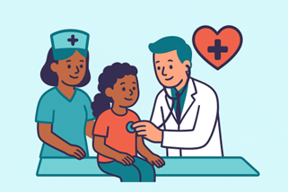 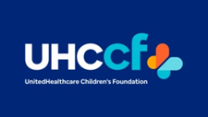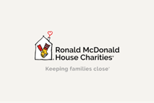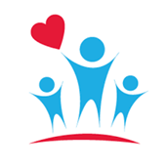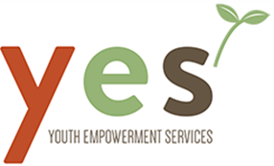
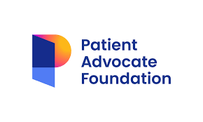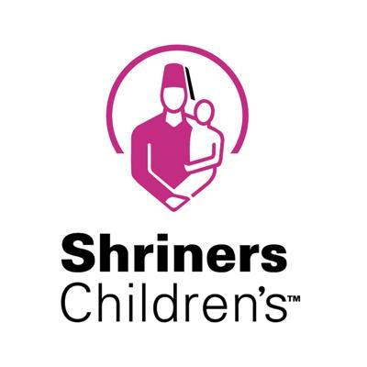

Healthy Kids, Happy Heart: Ensuring a child's health can be expensive and overwhelming. That's why we've gathered trusted non-profits across the nation that provide financial support, medical care, and emotional guidance- because every child deserves the chance to thrive.

  - United Healthcare Children’s Foundation: Provides medical grants for expenses that are not covered by health insurance
  - Idaho Parents Unlimited: Helps families of children with special needs get the support they need, from funding to training

Ronald McDonald House Charities: Assists families with housing and meals as they support their ill child
  - Family Voices: Supports families with children who have special needs through its various programs
  - Child Mind Institute: Supports children and teens facing mental health issues through its various programs

Youth Empowerment Services: Assists Idaho children who have mental health needs and a physical disability. HealthWell Foundation: Helps families cover out-of-pocket medical costs such as co-pays, premiums, and medications.

Patient Advocate Foundation: Provides financial aid and case management for families dealing with serious illnesses

The Assistance Fund: Offers financial support for children with chronic or life-threatening conditions

Shriners Children’s: Offers specialized medical care for children regardless of ability to pay

Education Page:
Image: 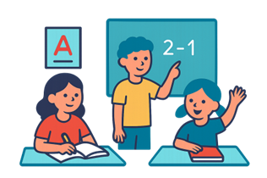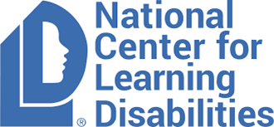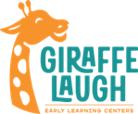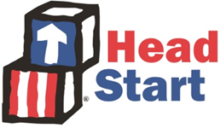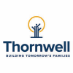
- Growing Minds & Bright Futures: Education empowers children to build the knowledge, confidence, and skills they need to grow & thrive. We’ve provided trusted non-profits nationwide that are dedicated to supporting every child’s learning journey.

  - National Center for Learning Disabilities: Provides resources and scholarships for children with learning disabilities.
  - Giraffe Laugh Early Learning Centers: Offers a tuition scholarship for families that need temporary support or don’t qualify for Idaho’s state support.
  - Head Start /Early Head Start: Offers free early education and other resources to low-income families
  - Big Brothers Big Sisters: Offers mentorship to children from the ages of 5 to 18. These individuals are paired with someone who is older than they are to foster meaningful relationships and inspiration.
  - Child Mind Institute: Supports the education of children with mental health or learning disorders.
  - Thornwell: Provides various resources, including educational support for families in SC.
  - Jack Kent Cooke Foundation: Provides scholarships and academic support for high-achieving students with financial need.
  - Khan Academy: Provides free online lessons, practice exercises, and tutoring for students of all ages.
  - Child Care Aware of America: Helps families find affordable childcare and financial assistance programs.
  - Scholarships.com: Helps families find scholarships and financial aid opportunities for students
Safety Page:
Images: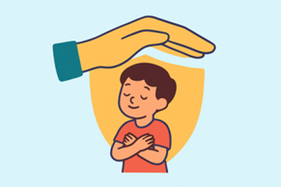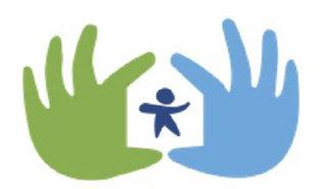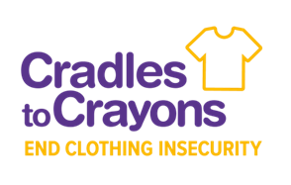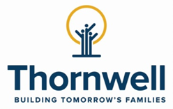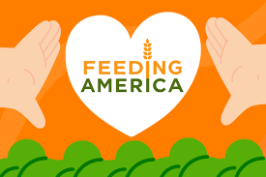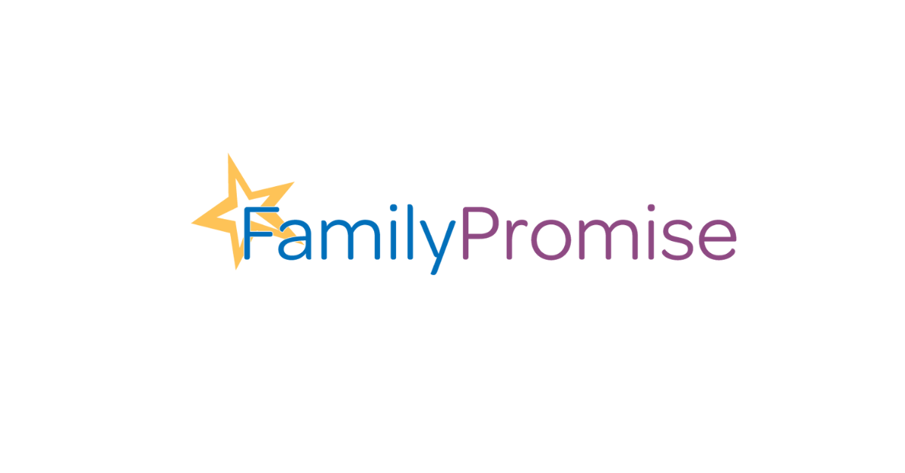

- Keeping Every Child Safe & Sound: Every child deserves to grow up feeling safe, supported, and valued. We’ve gathered trusted nonprofits that provide protection, emergency support, and essential resources to help children and families navigate difficult situations.

  - Safe Families For Children: Provides a safe, temporary home for children in order to allow caregivers the chance to focus on crises.
  - Charlie’s House: Offers resources to help parents and caregivers prevent accidents and fatal injuries to kids in and around the home.
  - YWCA: Offers various programs for children and teens who have been affected by domestic abuse.
  - La Casa de Las Madres: Provides 24/7 crisis hotlines and family violence shelters.
  - Cradles to Crayons: Provides children with high-quality clothing. The clothing can be packed and shipped directly to the children who need it.
  - Thornwell: Provides various resources, including support for children and families who are struggling with living in a new home from previous abuse or need to be placed in a loving home.
  - Dave Thomas Foundation for Adoption: Helps children in foster care find permanent, loving homes.
  - Baby2Baby: Provides diapers, clothing, and basic necessities to children living in poverty.
  - Family Promise: Helps families facing homelessness find shelter and regain stability.
  - Feeding America: Supplies food through a nationwide network of food banks, helping families in crisis.
Crisis Page:

- You are not alone. If you or someone you know is in crisis, help is available 24/7. These resources are confidential and free.
- * If this is an emergency, please call 911 immediately*
- * For immediate suicide prevention, please call or text 988*
- Immediate Crisis Support:
  - Crisis Text Line: Text HOME to 741741, Free 24/7 crisis support via text
  - National Child Abuse Hotline: 1-800-422-4453, Childhelp National Abuse Hotline
  - National Runaway Safeline: Help for runaway and homeless youth
  - Nation Safe Place: Connect kids to safe locations(Libraries, fire stations, etc.)

- Safety Planning:

  - If you need help now:
    - Call 911 if you or someone is in immediate danger
    - Reach out to a trusted adult - teacher, counselor, family member
    - Use one of the crisis hotlines listed above
    - Go to a safe place away from danger

  - Creating a Safety Plan:
    - Identify trusted adults you can contact
    - Know safe places you can go to in your community
    - Keep important phone numbers easily accessible
    - Have a plan for leaving dangerous situations quickly

Wireframes

Home Page- 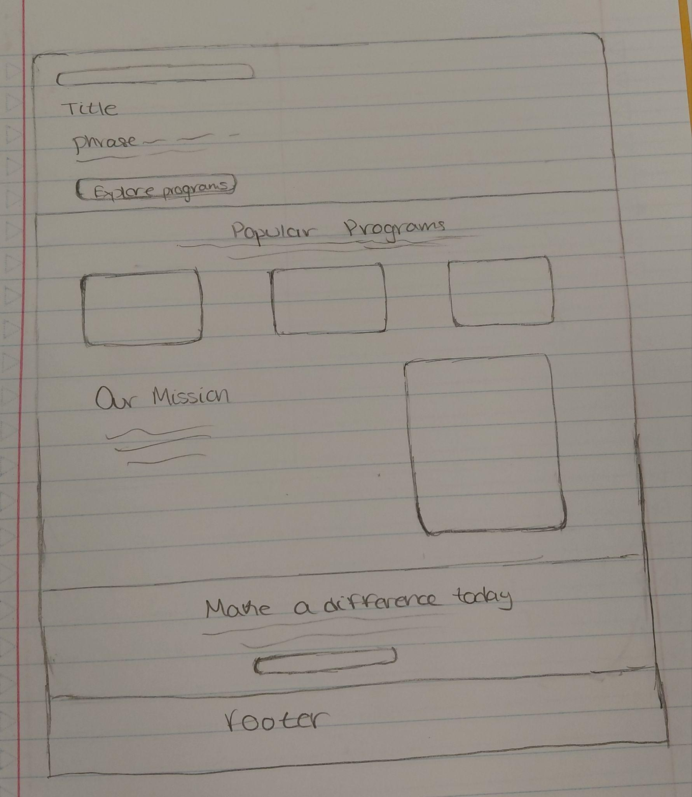
Child Page Desktop - 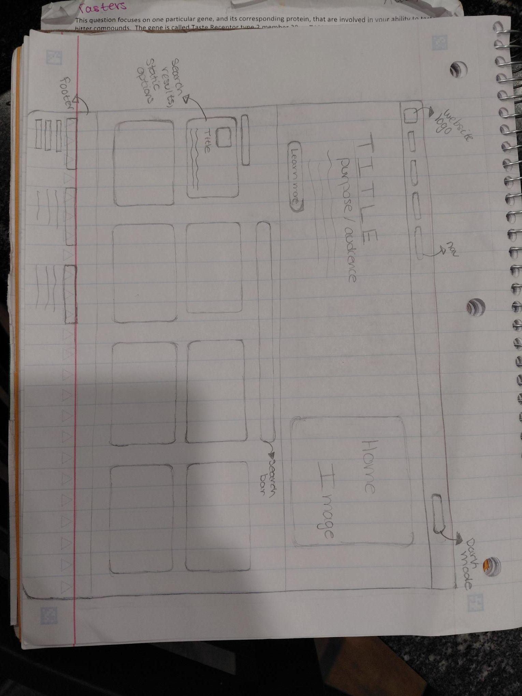

Child Page Mobile - 